INTERNATIONAL AFRICAN–MIDDLE EASTERN CONGRESS
ON ANTHROPOLOGY AND DIALOGUE BETWEEN PEOPLES
Lyon, France | 9–11 April 2027
“Humanity at the Heart of Transformations: Identities, Cultures and Interactions Between Peoples”

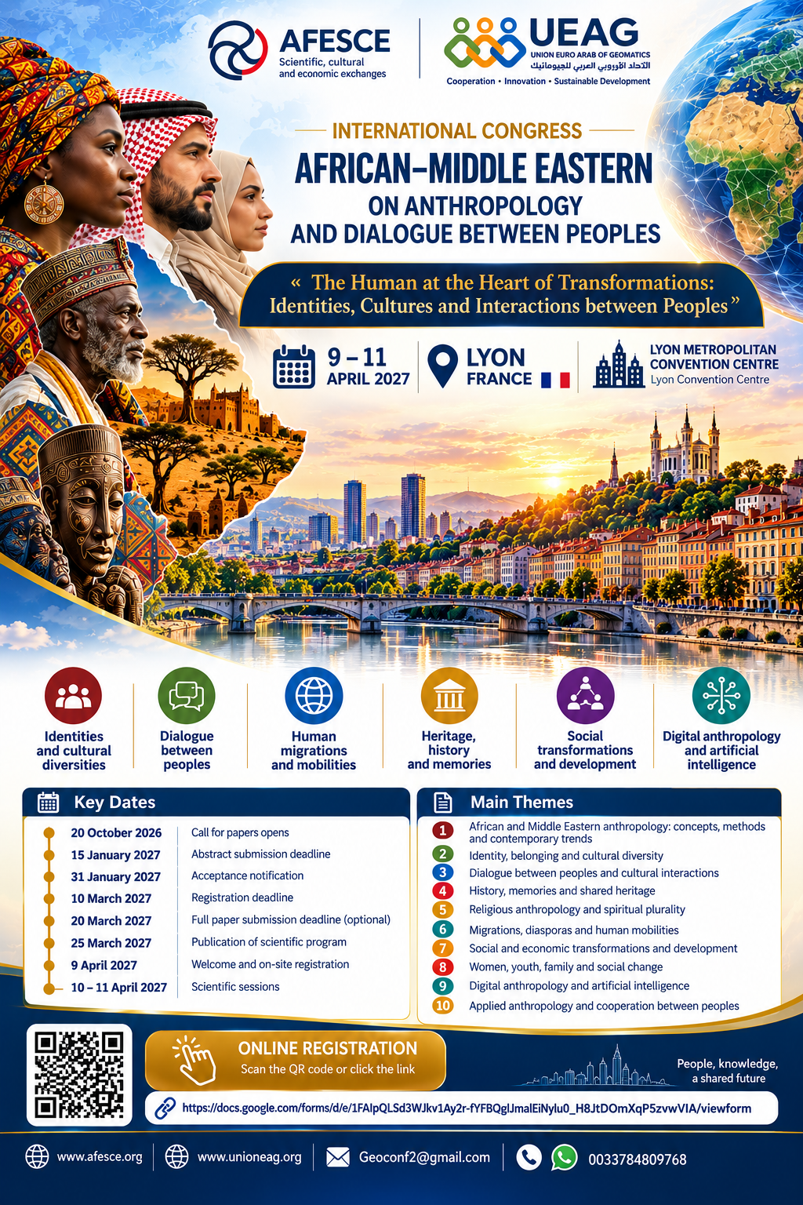

Lyon 2027… A Meeting Place for Thought, Knowledge and Dialogue Between Peoples
Under the theme “Humanity at the Heart of Transformations: Identities, Cultures and Interactions Between Peoples”, Lyon, France, will host the International African–Middle Eastern Congress on Anthropology and Dialogue Between Peoples from 9 to 11 April 2027. This international academic event will bring together researchers, scholars, experts and representatives of universities, research centres and scientific and cultural institutions from Africa, the Middle East, Europe and across the world.
The Congress aims to provide an international forum for scientific dialogue, knowledge-sharing and the exchange of experience. It will address the social and cultural transformations of our time and explore questions of identity, cultural diversity, migration, heritage and human relations, highlighting the contribution of anthropology and the humanities and social sciences to understanding societies and strengthening cooperation between peoples.
We are pleased to invite researchers, university professors, experts, postgraduate students, universities, research centres and scientific and cultural organisations to participate actively, present their research and initiatives, enrich the academic debate and open new avenues for international cooperation and partnership.
Our ambition goes beyond organising an academic gathering: we seek to create a lasting space for exchanges among researchers and institutions, foster joint scientific and cultural initiatives, make knowledge a bridge between peoples, celebrate diversity as a source of enrichment and place dialogue at the foundation of mutual understanding and cooperation.
Join this international scientific event and help build bridges of knowledge and dialogue between Africa, the Middle East and Europe.

Initiating Organisations
- French Association for Scientific, Cultural and Economic Exchanges (AFESCE).
- Euro-Arab Union of Geomatics (UEAG).
In cooperation with international academic, research and cultural institutions, whose partnerships will be announced once confirmed.

I. General Presentation of the Congress
The contemporary world is experiencing profound and rapid changes that are reshaping the relationship between individuals and their social and cultural environments, while raising new challenges concerning identity, belonging, cultural diversity, migration, collective memory and economic, technological and environmental change.
Against this backdrop, there is a growing need for scientific approaches capable of understanding societies in all their diversity and complexity and examining how peoples interact and communicate.
Africa and the Middle East occupy a central place in this discussion because of the deep historical, geographical, cultural, religious and economic links among their societies, forged over centuries through human mobility, trade and the exchange of knowledge, languages, beliefs and traditions.
These interactions have shaped plural social and cultural spaces in which identities and affiliations intersect and human experiences unfold across local, regional and global settings.
Understanding these relationships requires moving beyond traditional approaches that view civilisations as separate, homogeneous entities, towards studying peoples and societies in their internal diversity through everyday experiences, cultural practices, social relationships and historical and contemporary transformations.
Anthropology offers an essential framework for understanding human beings, culture and society, drawing on theoretical and methodological tools and field-based approaches to analyse social practices, cultural representations and cross-border human relationships.
It is in this spirit that the International African–Middle Eastern Congress on Anthropology and Dialogue Between Peoples will take place in Lyon, France, from 9 to 11 April 2027, as an international academic forum for dialogue and the exchange of knowledge and experience among researchers, university professors, experts and representatives of scientific and cultural institutions from Africa, the Middle East, Europe and beyond.
The Congress seeks to renew the scientific and human understanding of dialogue by moving from general discourse on the dialogue of civilisations towards the study of real interactions between peoples, while highlighting the role of anthropological research in understanding social and cultural diversity, mutual knowledge and human cooperation.
It also aims to build sustainable academic and institutional partnerships and encourage comparative studies, field research and joint scientific projects that advance knowledge of African and Middle Eastern societies and their relationships with the wider world.

II. Scientific Vision and Central Research Question
The Congress places human beings at the centre of the analysis of social transformations and cultural interactions. Dialogue between peoples rests not only on the exchange of ideas and statements, but also on reciprocal scientific knowledge and an understanding of the social, cultural and historical particularities of societies.
This vision calls for stronger complementarity between anthropology and the humanities and social sciences in examining identity, belonging, migration, cultural diversity and social change from multiple perspectives.

Central Research Question
How can anthropology and the humanities and social sciences contribute to understanding the cultural and social transformations affecting African and Middle Eastern societies, and analysing relations and interactions between peoples, in ways that strengthen mutual knowledge, recognition of cultural diversity and new possibilities for human and scientific cooperation?
Related questions concern the formation of identities, the effects of migration and globalisation, the roles of religion, language, heritage and collective memory, technological change, mechanisms of coexistence and research cooperation among African, Middle Eastern and European institutions.

III. Objectives of the Congress

Scientific Objectives
- Strengthen anthropological research on African and Middle Eastern societies.
- Develop interdisciplinary field studies and comparative research.
- Discuss contemporary theoretical and methodological developments in anthropology.
- Encourage scientific knowledge grounded in local contexts.
- Support early-career researchers and master’s and doctoral students.
- Promote scholarly publication and joint research projects.

Cultural and Human Objectives
- Improve mutual understanding between peoples.
- Highlight cultural, linguistic and religious diversity.
- Study historical and contemporary interactions between Africa, the Middle East and Europe.
- Draw attention to tangible and intangible heritage and collective memory.
- Support cultural and human initiatives promoting understanding and coexistence.

Institutional Objectives
- Develop cooperation among universities, research centres and cultural institutions.
- Encourage partnership agreements and academic exchanges.
- Support joint scientific projects.
- Explore the establishment of an international network for anthropology and dialogue between peoples.
- Identify opportunities for international scientific and cultural funding.

IV. Scientific Themes

Theme 1 – African and Middle Eastern Anthropology: Concepts, Methods and Contemporary Approaches
Examines the development of anthropological studies in Africa and the Middle East, theoretical and methodological shifts, critiques of colonial legacies in knowledge production, and local and comparative approaches.
Subtopics:
- History of anthropology in Africa and the Middle East
- Contemporary anthropological schools and trends
- Postcolonial anthropology and critiques of epistemic centrality
- Ethnography and field research methods
- Comparative anthropology and transnational studies
- Local knowledge and participatory approaches
- Ethics of anthropological research

Theme 2 – Identity, Belonging and Cultural Diversity
Explores the formation of individual and collective identities and the relationship between cultural and social belonging and contemporary change.
Subtopics:
- Cultural and social identity
- Ethnic and linguistic plurality
- National identity and transnational belonging
- Multiculturalism and social integration
- Generational change and the reshaping of identity
- Minorities and societal diversity
- Stereotypes and mutual representations

Theme 3 – Dialogue Between Peoples and Cultural and Human Interactions
Studies relations between peoples from an anthropological perspective, examining communication and cultural and social interaction.
Subtopics:
- Dialogue between peoples: concepts and scientific approaches
- Cultural relations among Africa, the Middle East and Europe
- Cross-border human interactions
- People-to-people and cultural diplomacy
- Cultural and social mediation
- Intercultural communication
- Coexistence and community solidarity
- The role of arts, education and civil initiatives in bringing peoples closer

Theme 4 – History, Memory and Shared Heritage
Examines historical and cultural connections between African and Middle Eastern societies and the role of memory and heritage in shaping identities and belonging.
Subtopics:
- Historical relations between Africa and the Middle East
- Trade routes, migration and knowledge transmission
- Collective memory and oral histories
- Tangible and intangible heritage
- Museums and cultural institutions
- Colonialism and postcolonialism
- Heritage restitution and the preservation of cultural memory
- Shared heritage and civilisational interactions

Theme 5 – Anthropology of Religion and Spiritual Diversity
Explores religious and spiritual beliefs and practices and their relationships with social and cultural structures.
Subtopics:
- Anthropology of religion
- Spiritual beliefs and practices
- Religion, identity and belonging
- Religious diversity and coexistence
- Religious institutions and their social roles
- Sacred places and religious memory
- Popular religious practices
- Interactions between religious traditions and local cultures

Theme 6 – Migration, Diasporas and Human Mobility
Approaches migration as a social and cultural phenomenon that reshapes identities, family relations and communities.
Subtopics:
- African and Arab migration to Europe
- Diasporas and transnational identities
- Migration and social integration
- Borders and human mobility
- Academic and professional migration
- Families, migration and societal change
- Transnational solidarity networks
- Migration, memory and belonging

Theme 7 – Social and Economic Transformations and Development
Examines changes arising from economic, urban and environmental developments and the anthropological understanding of development policies.
Subtopics:
- Economic anthropology
- Rural and urban societies
- Urbanisation and spatial change
- Informal economies
- Local development and community participation
- Climate change and social transformations
- Natural resources and social justice
- Development policies from an anthropological perspective

Theme 8 – Women, Youth, Family and Societal Change
Studies changes in family, gender and intergenerational relations and the roles of women and young people in contemporary societies.
Subtopics:
- Family, kinship and social change
- Women and community participation
- Youth, identity and culture
- Gender and social relations
- Education and generational transformations
- Work and economic participation
- Demographic change
- Intergenerational relations

Theme 9 – Digital Anthropology and Artificial Intelligence
Explores the impact of digital technology and artificial intelligence on cultures, social practices and human relationships.
Subtopics:
- Digital ethnography
- Artificial intelligence and cultural transformations
- Social media and human relationships
- Virtual communities and digital identities
- Digital cultural heritage
- Digital archiving of collective memory
- Data ethics and digital research
- Geospatial and digital technologies in anthropological studies

Theme 10 – Applied Anthropology and Cooperation Between Peoples
Considers the use of anthropological knowledge in cultural, social and development policies and the strengthening of joint initiatives.
Subtopics:
- Anthropology and public policy
- Social and cultural mediation
- Education for diversity and coexistence
- Participatory research with local communities
- International academic and scientific cooperation
- Anthropology and sustainable development
- Cross-border cultural and social initiatives
- Anthropological knowledge and human partnerships

V. Who Is Invited to Participate?
- University professors and researchers in anthropology, humanities and social sciences.
- Scholars specialising in African and Middle Eastern studies.
- Master’s and doctoral students and early-career researchers.
- Directors of laboratories and scientific research centres.
- Specialists in heritage, museums and cultural studies.
- Researchers working on migration, identity and cultural diversity.
- Representatives of universities and scientific and cultural institutions.
- International organisations and specialist academic associations.
- Institutions, organisations and companies interested in scientific and cultural cooperation and social responsibility.
The Congress welcomes theoretical, field-based and comparative research as well as academic initiatives that foster international research cooperation.

VI. Scientific Participation Requirements
Papers may be presented in Arabic, French or English. Researchers wishing to participate should submit:
- Title of the proposed presentation.
- An abstract of 300–500 words.
- Four to six keywords.
- Full name(s) of the author(s).
- Academic position and university or institutional affiliation.
- Email address and contact details.
- A short academic biography.
Abstracts will be reviewed by the International Scientific Committee on the basis of originality, clarity of the research question, methodological soundness and relevance to the Congress themes.
Presentation length: 15–20 minutes, subject to the final programme. Congress languages: Arabic, French and English; available interpretation arrangements will be announced later.

VII. Key Dates and Deadlines
Activity | Date
Call for papers and registration open | 20 October 2026
Abstract submission deadline | 15 January 2027
Early registration deadline | 15 January 2027
Notification of abstract review results | 31 January 2027
Late registration period | 16 January – 10 March 2027
Final registration deadline | 10 March 2027
Optional full-paper submission deadline for publication consideration | 20 March 2027
Final scientific programme announced | 25 March 2027
Delegate reception and on-site registration | 9 April 2027
Scientific sessions | 10–11 April 2027
Note: Authors who submit their abstracts by 15 January 2027 remain eligible for the early rate for 15 days after receiving their acceptance notification, provided they complete registration and payment within that period.
Conference Leadership and International Scientific Council
Conference President
Dr Mohamed Ayari — President of the Euro-Arab Union of Geomatics and the French Association for Scientific, Cultural and Economic Exchange.
Scientific Council Chair
Prof. Mohamed Ziyadi — France
Scientific Council Vice-Chair
Dr Joseph P. SAHGUI — Benin. Full Professor (CAMES), historian and development sociologist specializing in migration issues. Lecturer and researcher at the University of Abomey-Calavi; Vice-Dean of FLASH/Adarra.
Scientific Council Members
Salomé DEBOOS — France
Full Professor of Social and Cultural Anthropology, specializing in religion, migration and new urbanities. Director of the Laboratory of Anthropology of Contemporary Issues (LADEC), Lumière Lyon 2 University, Department of Anthropology, Sociology and Political Science
Farid El Asri — Morocco
Professor, Chair of Cultures, Societies and Religious Phenomena; College of Social Sciences, International University of Rabat
Mamadou Dramé — Senegal
Full Professor and Assesseur, FASTEF, Cheikh Anta Diop University of Dakar
El Hadji Malick Sy Camara — Senegal
Professeur Assimilé in sociology and anthropology, Faculty of Arts and Humanities, Cheikh Anta Diop University of Dakar
Rachid Jarmouni — Morocco
Professor of sociology, Moulay Ismail University, Meknes; visiting professor, Doha Institute for Graduate Studies, Qatar
Dr Boubacar BARRY – Senegal
Socio-anthropologist, Assane Seck University of Ziguinchor, Senegal.
Khalid Mouna — Morocco
Full Professor, Moulay Ismail University, Meknes
Najima Thay Thay — Morocco
Academic researcher and former minister in Morocco
Sana Chami — Italy
Academic researcher; External Relations and International Cooperation Officer, Venice Association for Italian-Arab Friendship
Hospice Bienvenu Hounyoton — Benin
Socio-anthropologist, permanent lecturer-researcher, FASHS-Adjarra / University of Abomey-Calavi; interculturality and human-rights expert; Chief of Staff, Djidja Municipality
Rachid ID YASSINE — Senegal
Maître de conférences in sociology, anthropology and religious studies, Gaston Berger University; affiliated with an international research consortium in Morocco studying socio-educational change and AI
Digital Coordination and Technical Preparation Committee
- Eng. Helmi Lamouchi – Tunisia
- Eng. Aman Allah Zoubir – France

VIII. Registration and Participation Fees
To facilitate participation by scholars, postgraduate students and institutions, the Organising Committee offers two registration phases.
Participant category | Early registration (until 15 Jan 2027) | Late registration (until 10 Mar 2027)
Master’s and doctoral students | €300 | €350
University professors and researchers | €350 | €450
Institutions, organisations and companies | €450 | €600

Phase One: Early Registration
20 October 2026 – 15 January 2027. The standard rates listed above apply, subject to the registration conditions.

Phase Two: Late Registration
16 January – 10 March 2027. An additional €50 applies to students, €100 to professors and researchers, and €150 to institutions, organisations and companies. Late registrations are subject to availability.
The institutional/organisational/company fee covers one representative. Special arrangements may be agreed for delegations with multiple participants.

Included in the Fees
- Access to scientific sessions, lectures and workshops.
- Congress kit and scientific and organisational documents.
- Certificate of attendance or presentation, as applicable.
- Coffee breaks on both scientific days.
- Electronic abstract book when published.
- Participation in scientific networking and academic cooperation meetings.

Not Included
Travel, visa fees, hotel accommodation, lunches, dinners and personal transportation expenses are not included.

Registration and Payment Conditions
- The early rate applies to participants who meet the early registration requirements.
- Late rates apply after the early registration period, subject to the payment grace period for abstracts submitted on time.
- Registration is final only after payment and confirmation by the Organising Committee.
- Academic acceptance of an abstract does not automatically confirm financial registration.
- Payment methods, cancellation terms and refund conditions will be announced before payments are collected.
- A scientific acceptance letter may be issued following the Scientific Committee’s decision.
- An invitation or acceptance letter does not guarantee a visa for entry into France.

IX. Scientific Publication
The Congress seeks to encourage academic publication through:
- Preparation of a book of accepted abstracts.
- Consideration of selected papers for a peer-reviewed collective academic publication.
- Cooperation with specialised academic journals and university institutions.
- Support for joint publications by researchers from Africa, the Middle East and Europe.
Full papers are subject to the peer-review standards of the relevant publisher. Acceptance of an abstract does not guarantee final publication.

X. General Congress Programme

Friday, 9 April 2027 – Delegate Reception and Registration | 14:00–19:00
- Welcome of international participants and delegations.
- Registration, badges and distribution of Congress materials.
- Organisational and logistical information.
- Informal introductions and networking.

Saturday, 10 April 2027 – Opening and Scientific Sessions | 10:00–17:30
- Official opening of the Congress.
- Addresses by organisers and partners.
- Opening keynote lecture.
- Scientific sessions on anthropology, identity and social transformations.
- Sessions on dialogue between peoples and cultural interactions.
- International roundtable on African–Middle Eastern relations and prospects for cooperation.

Sunday, 11 April 2027 – Specialised Sessions and Closing | 10:00–17:00
- Specialised scientific sessions.
- Research workshops and field studies.
- Early-career researcher sessions.
- University cooperation and research partnership meetings.
- Presentation of outcomes and recommendations.
- Closing ceremony and distribution of participation certificates.
The detailed scientific programme, keynote speakers and session chairs will be announced after the review of submissions and confirmation of invitations.

XI. Scientific and Institutional Partnerships
The Congress seeks to establish partnerships with universities, research centres, laboratories, cultural institutions and international organisations engaged in anthropological studies and academic cooperation. Proposed areas of collaboration include:
- Membership of the International Scientific Committee.
- Nomination of keynote speakers and specialist contributors.
- Peer review of abstracts and papers.
- Support for early-career researchers and doctoral students.
- Cooperation on academic publication.
- Development of joint research projects.
- Academic exchange and cooperation agreements.
- Organisation of parallel scientific and cultural activities.
Institutions interested in joining academic and organisational partnerships are welcome to contact the organisers to discuss suitable arrangements.

XII. Expected Outcomes
- Strengthen anthropological knowledge about African and Middle Eastern societies.
- Encourage comparative research and joint field studies.
- Expand cooperation among universities and research centres.
- Support early-career researchers in international scientific activities.
- Initiate cooperation in heritage, migration, identity and culture.
- Explore the establishment of an international scientific network for anthropology and dialogue between peoples.
- Develop actionable scientific and institutional recommendations.
- Sustain collaboration after the Congress through joint projects and meetings.

Contact and Abstract Submissions
Geoconf2@gmail.com
www.afesce.org | www.unioneag.org
0033784809768

